**DIAGNOSIS OF DERMATOLOGICAL DISEASES USING 3D PROJECTION**

**A PROJECT REPORT**

***Submitted by***

**BALAJI PRASANTH E 211416106033**

**DINESH R 211416106057**

**KANMANIVISHWAA P 211416106113**

**KHANISHKHA S V 211416106122**

***in the partial fulfillment for the award of the degree***

***Of***

**BACHELOR OF ENGINEERING**

***In***

**ELECTRONICS AND COMMUNICATION**

**PANIMALAR ENGINEERING COLLEGE**

**ANNA UNIVERSITY : CHENNAI 600 025**

**APRIL -2020**

**ANNA UNIVERSITY : CHENNAI 600 025**

**BONAFIDE CERTIFICATE**

Certified that this project report **“DIAGNOSIS OF DERMATOLOGICAL DISEASES USING 3D PROJECTION”** is the bonafide work of **BALAJIPRASANTH E (211416106033)**, **DINESH R (211416106057), KANMANIVISHWAA P (211416106113), KHANISHKHA SV (211416106122)** who carried out the project work under my supervision.

**SIGNATURE SIGNATURE**

**Dr.P.KANNAN, M.E,PhD Dr.S.MAGESHWARI, M.E,PhD**

**HEAD OF THE DEPARTMENT, PROFESSOR,**

Dept of Electronics and Communication, Dept of Electronics and Communication,

Panimalar Engineering College, Panimalar Engineering College,

Poonamallee, Poonamallee,

Chennai-600123 Chennai-600123

**ABSTRACT**

* Dermatological diseases have a serious impact on people’s life and health. Current research proposes an efficient approach to identify unique skin diseases.
* It is necessary to develop automatic methods in order to increase the accuracy of diagnosis for multi-type skin diseases. Image segmentation is a technique which aids with the detection of skin diseases.
* In this project, image processing techniques like adaptive thresholding, edge detection are being used. Depending on the definite pattern (pertaining to a distinct disease) input image is subjected to 3d conversion, then the diagnosis takes place. For K-means clustering and morphology-based image segmentation have been used to identify the skin diseases from the given image set. The texture and colour features of different skin disease images could be obtained accurately.
* Images acquired using a smartphone under loosely-controlled environmental conditions may be subject to various distortions, and this makes melanoma detection more difficult.
* Second, processing performed on a smartphone is subject to stringent computation and memory constraints. In this system a detection system that is optimized to run entirely on the resource-constrained smartphone.

### ACKNOWLEDGEMENT

We have immense pleasure in the successful completion of my project work titled **“DIAGNOSIS OF DERMATOLOGICAL DISEASES USING 3D PROJECTION”.**

We owe a debt of gratitude to my dynamic and honorable **Founder/Chairman(late) Col. Dr. JEPPIAAR, M. A., B. L., Ph. D.,** for his sincere endeavor in educating me in his premier institution. We express our heartfelt thanks and sincere acknowledgement to our respected **Secretary and Correspondent, Dr. P. CHINNADURAI, M. A., Ph.D.,** for his kind motivation and support in completion of this project.

Our special gratefulness to the vibrant **Directors, Tmt. C. VIJAYARAJESWARI** and **Mr. C. SAKTHI KUMAR, M.E., M.Phil.,** who are focused in bringing out the true potential of all the students. We would like to express our deep appreciation to my **Principal, Dr. K. MANI, M.E., Ph.D.,** for the encouragement he has given me in completion of this project.

It is our privilege to thank **Dr. P. KANNAN, M.E., Ph.D., Professor and Head of the Department,** Electronics and Communication Engineering, for his keen interest on me at every stage of my project work from inception to completion. His prompt inspirations, timely suggestions with kindness, enthusiasm and dynamism have enabled me to complete my project work.

I am greatly indebted to the motivation and understanding extended for the project work by my supervisor **Dr.S.MAGESHWARI,M.E,PhD**.,

**Professor,** Department of Electronics and Communication Engineering, who responded promptly and enthusiastically to my requests, despite her congested schedules. I am obliged to all the staff member of our department, who did their best to bring improvements through their suggestions.

Additionally, I thank my college library staff and administrative staff, who always supported my educational activities and facilitated my work on this project. It is a genuine pleasure to express my deep sense of thanks to the Almighty, for the vision and foresight which inspired me to conceive this project work. I like to thank my parents who fulfilled my dreams.

**TABLE OF CONTENTS**

**CHAPTER TITLE PAGE NO:**

**ABSTRACT** iii

**LIST OF TABLES** vi**i**

**1. INTRODUCTION**   **1**

1.1 HISTORY 2

1.2 SKIN TESTS 3

**2. LITERATURE SURVEY 4**

**3. CONVOLUTIONAL NEURAL NETWORK 8**

3.1 INTRODUCTION 9

3.2 ARCHITETURE-CNN 10

3.3 ADVANTAGES-CNN 16

**4. IMAGE PROCESSING 17**

4.1 MATLAB IMAGE PROCESSING 19

4.2 MATLAB SYSTEM AND PARTS 20

**5. DIGITAL IMAGE PROCESSING 22**

5.1

5.2

5.3 ADVANTAGES OF DIGITAL IMAGE

**6. METHODOLOGY**

6.1 PRE-PROCESSING

6.2 SEGMENTATION

6.3 MEDICAL IMAGE SEGMENTATION

6.4 3D RECONSTRUCTION

6.5 FEATURE EXTRACTION

6.6 CLASSIFICATION

**7. MODULES**

7.1 MODULES DESCRIPTION

**8. CONCLUSION**

**REFERENCES**

**LIST OF FIGURES**

**FIGURE TITLE PAGE NO**

3.1 Architecture of ConvNet 10

3.2 Feature Map 11

3.3 LesNet-5 12

3.4 AlexNet 12

3.5 ZFNet 13

3.6 GoogleNet 14

3.7 VGGNet 15

3.8 ResNet 16

3.9 Analaysis of practical applications 17

5.1 Architecture diagram

**CHAPTER 1**

**INTRODUCTION**

Dermatology is the branch of medicine dealing with the hair, nails, skin and its diseases. It is a specialty with both medical and surgical aspects. A dermatologist takes care of diseases, in the widest sense and some cosmetic problems of the skin, scalp, hair, and nails.

Human skin is one of the most unpredictable and difficult terrains to automatically synthesize and analyze due to its complexity of jaggedness, tone, presence of hair and other mitigating features. In a developing country like Bangladesh it is expensive for a large number of people to go to dermatologist for their skin disease problem.

Every year a large number of populations in the developing countries like Bangladesh suffer due to different types of skin diseases. So, it is very necessary for both the patients and dermatologists to have an automated skin disease detection system especially in developing countries. Even though there have been several researches conducted to detect dermatological skin diseases using Computer Vision based techniques.

Detecting different types of skin diseases from color image is a very challenging task in computer vision. Finding out different features from the color skin images of the infected area of different skin diseases and detecting them.

**1.1-HISTORY**

Skin diseases have a serious impact on people’s life and health. Current research proposes an efficient approach to identify singular type of skin diseases. It is necessary to develop automatic methods in order to increase the accuracy of diagnosis for multitype skin diseases. In this paper three type skin diseases such as herpes, dermatitis, and psoriasis skin disease could be identified by a new recognition method. Initially, skin images were preprocessed to remove noise and irrelevant background by filtering and transformation. Then the method of grey-level co-occurrence matrix (GLCM) was introduced to segment images of skin disease

**1.2-SKIN TESTS**

A variety of skin tests may be performed to diagnose skin allergies, bacterial, viral, or fungal skin infections, and other problems affecting the skin. Skin tests are also performed to tell the difference between malignant (cancerous) cells and benign (noncancerous) growths.

The most common skin tests include:

* Patch testing: Patch tests are used to help diagnose skin allergies. Identified allergens (substances that a person may be allergic to) are applied to the skin on the back with adhesive patches and left for a period of time. The skin is then examined for any reaction.
* Skin biopsy: Skin biopsies are performed to diagnose skin cancer or benign skin disorders. During a skin biopsy, skin is removed (after a local anesthetic is applied) and is taken to a laboratory for analysis. Skin may be removed with a scalpel, Gillette blue blade, or a cylindrical punch biopsy tool. Stitches may be used to close the wound.
* Culture: A culture is a test that is done to identify the microorganism (bacteria, fungus, or virus) that is causing an infection. Skin (surface scrapings, biopsies, contents of pus bumps and blisters), hair, or nails may be cultured to detect bacteria, fungi, or viruses.

Dermatology is one of the most unpredictable and difficult terrains to diagnose due its complexity. In the field of dermatology, many a times extensive tests are to be carried out so as to decide upon the skin condition the patient may be facing. The time may vary from practitioner to practitioner. This is also based on the experience of that person too. So, there is a need of a system which can diagnose the skin diseases without any of these constraints. We propose an automated image-based system for recognition of skin diseases using machine learning classification. This system will utilize computational technique to analyze, process, and relegate the image data predicated on various features of the images. Skin images are filtered to remove unwanted noise and also process it for enhancement of the image. Feature extraction using complex techniques such as Convolutional Neural Network (CNN), classify the image based on the algorithm of SoftMax classifier and obtain the diagnosis report as an output. This system will give more accuracy and will generate results faster than the traditional method, making this application an efficient and dependable system for dermatological disease detection. Furthermore, this can also be used as a reliable real time teaching tool for medical students in the dermatology stream.

**CHAPTER 2**

**LITERATURE SURVEY**

1. Clinical Skin Lesion Diagnosis Using Representations Inspired by Dermatologist Criteria

Author: Jufeng Yang, Xiaoxiao Sun, Jie Liang, Paul L. Rosin – 2018

In this paper the problem of clinical skin lesion diagnosis, which is challenging compared to skin cancer recognition on dermatoscopic images. It verifies that the criteria employed by clinicians in the diagnosis process can be measured by computers. Accordingly, it design six discriminative and interpretable representations for distinguishing skin lesions by incorporating the accepted dermatological criteria. Experiments on benchmark dataset demonstrate the proposed representations outperform both the low-level features and the deep features. Furthermore, the final performance on clinic images with 198 categories of skin disease is comparable with dermatologists.

2. Statistical Investigation of Skin Image for Disease Analyzing in Rural Area Using Matlab

Author: Zulfikar Zulfikar and Zulhelmi Zulhelmi – 2017

The purpose of the study is to find the unique characteristics of an image for digital processing purposes. Fast and simple processing is necessary for analyzing skin diseases, especially in remote areas where there is no or less medical support. Nine images that have been selected randomly its changed into three-dimensional matrices using Matlab. Then, the analysis is done in several color formats such as RGB, YCbcr, HSV and HSI. The images itre also analyzed after their contrast level was increased using contrast enhancement, histogram equalization, and contrast-limited adaptive histogram equalization techniques. Some statistical parameters such as mean, median and standard deviation are used as a reference in the analysis process. The most suitable color format for the above purposes is YCbCr and the most appropriate contrast enhancement technique if required is the histogram equalization.

3. Skin Disease detection based on different Segmentation Techniques

Author: Kyamelia Roy Sheli,Sinha Chaudhuri Sanjana Ghosh, Swarna Kamal Dutta Proggya Chakraborty Rudradeep Sarkar – 2019

In this paper, it performed four segmentation techniques on certain skin diseases namely- eczema, psoriasis, chicken pox and ringworm, intending to be informative regarding the detailed information relative to the images. The proposed method improves the segmentation using OpenCV with the help of python in separating the image on the basis of edge detection or region detection. For the four different disease images, four segmentation techniques are used and the resultant images are produced on the basis of Signal to Noise Ratio. The segmentation techniques show promising results differently for the four categories of diseases. In case of chicken pox adaptive thresholding is the best method. For eczema k-means clustering is the best method. Morphology based segmentation is the best method for detect psoriasis. In case of ringworm disease edge detection is the best method. However, at a large the applied segmentation procedure could be more efficient if it is coupled with the classification of the diseases, so as to act as a support to the clinicians for the analysis of the dermatologist.

4. Digital dermatology - Skin disease detection model using image processing

Author: Archana Ajith, Vrinda Goel, Priyanka Vazirani, Dr. M. Mani Roja - 2018

This paper proposes a skin disease detection method based on image processing techniques. This method is mobile based and hence very accessible even in remote areas and it is completely noninvasive to patient's skin. The patient provides an image of the infected area of the skin as an input to the prototype, Image processing techniques are performed on this image and the detected disease is displayed at the output. The proposed system is highly beneficial in rural areas where access to dermatologists is limited.

5. Detection and analysis of skin cancer using wavelet techniques

Author: D.N.V.S.L.S. Indira, JYOTSNA SUPRIYA - 2011

In this paper the skin cancer is detected using wavelet techniques and melanoma color and it presents a different method to develop a Texture Analysis based Classification Module to improve the decision strategy and overall accuracy of the system, Asymmetry, Border Irregularity, Color variation, Diameter the major symptoms which we will use in our processing algorithm. By applying multi-level Wavelet Transformation to the input image and then choosing a group of sub-bands to be restored for best defect detection, the procedure for Skin cancer detection and analysis was developed.

6. Using color signatures for the classification of skin diseases

Author: Nikos Petrellis - 2018

A skin disorder classification method is presented in this paper based on color signatures that can be defined using a small number of training photographs by the end user. The accuracy also quite high.

7. A Method for Melanoma Skin Cancer Detection Using Dermoscopy Images

Author: Soniya Mane, Dr. Swati Shinde 2018

Skin cancer is life threatening disease which causes human death. Abnormal growth of melanocytic cells talses a skin cancer. Due to malignancy feature skin cancer is also known as melanoma. Melanoma appears on the skin due to exposure of ultraviolet radiation and genetic factors. So melanoma lesion appears as black or brown in colour. Early detection of melanoma can cure completely. Biopsy is a traditional method for detecting skin cancer. This method is painful and invasive. This method requires laboratory testing so it is time consuming. Therefore, in order to solve the above stated issues computer aided diagnosis for skin cancer is needed. Computer aided diagnosis uses Dermoscopy for capturing the skin image. In this paper first pre-processing of the skin image is done. After pre-processing lesion part is segmented by using image segmentation technique which is followed by feature extraction in which unique features are extracted from segmented lesion. After feature extraction, classification by using support vector machine is performed for classifying the skin image as normal skin and melanoma skin cancer. The proposed system results shows that support vector machine with linear kernel gives optimum accuracy

8. Fingerprint damage localizer and detector of skin diseases from Finger print images

Author: Stepanka Barotova, Martin Drahansky – 2017

This paper developed algorithms that reach great quality in describing the overall extent of damage in a fingerprint image. The following methods were implemented for block orientation field, Histogram Analysis method and an extended Flood Fill. The best results were achieved by connecting the methods together using a Status Map. Along with the localizer, a classifier of four skin diseases was developed. It reached an accuracy of 83.5% for acrodermatitis, 45.3% for atopic eczema, 58.3% for psoriasis and 75.0% for verruca vulgaris.

**CHAPTER 3**

**CONVOLUTIONAL NEURAL NETWORK**

Artificial Intelligence has been witnessing a monumental growth in bridging the gap between the capabilities of humans and machines. Researchers and enthusiasts alike, work on numerous aspects of the field to make amazing things happen. One of many such areas is the domain of Computer Vision.

The agenda for this field is to enable machines to view the world as humans do, perceive it in a similar manner and even use the knowledge for a multitude of tasks such as Image & Video recognition, Image Analysis & Classification, Media Recreation, Recommendation Systems, Natural Language Processing, etc. The advancements in Computer Vision with Deep Learning has been constructed and perfected with time, primarily over one particular algorithm — a Convolution NeuralRFDWS0058 Network.

**3.1-INTRODUCTION**

A Convolution Neural Network (ConvNet/CNN) is a Deep Learning algorithm which can take in an input image, assign importance (learnable weights and biases) to various aspects/objects in the image and be able to differentiate one from the other. The pre-processing required in a ConvNet is much lower as compared to other classification algorithms. While in primitive methods filters are hand-engineered, with enough training, ConvNets have the ability to learn these filters/characteristics.

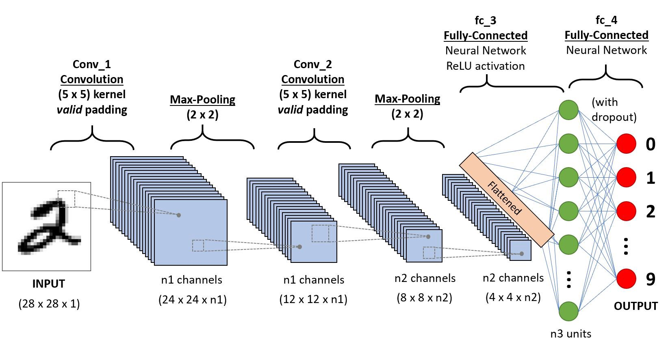

**Figure 3.1-Architecture of ConvNet**

The architecture of a ConvNet is analogous to that of the connectivity pattern of Neurons in the Human Brain and was inspired by the organization of the Visual Cortex. Individual neurons respond to stimuli only in a restricted region of the visual field known as the Receptive Field. A collection of such fields overlap to cover the entire visual area.

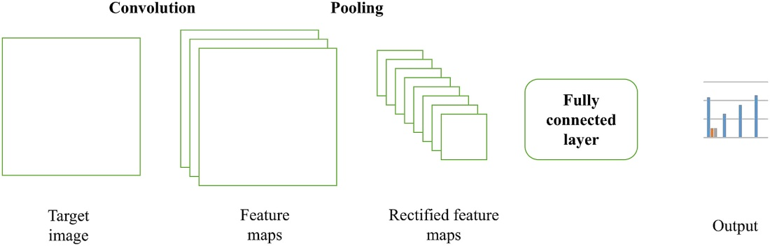

**Figure 3.2-Feature Map**

A **feature** map is formed by different units in a **CNN** that share the same weights and biases. For example: In the **feature** map above, imagine that each unit in layer m - 1 takes an input from a specific receptive field of the image, and the units in layer m receive inputs from layer m – 1.

**3.2-ARCHITECTURE OF CENTRAL NUERAL NETWORK**

The architecture of a ConvNet is analogous to that of the connectivity pattern of Neurons in the Human Brain and was inspired by the organization of the Visual Cortex. Individual neurons respond to stimuli only in a restricted region of the visual field known as the Receptive Field. A collection of such fields overlap to cover the entire visual area.

**LeNet-5(1998)**

LeNet-5,a pioneering 7-level convolutional network by LeCun et al in 1998, that classifies digits, was applied by several banks to recognise hand-written numbers on checks (cheques) digitized in 32x32 pixel greyscale inputimages. The ability to process higher resolution images requires larger and more convolutional layers, so this technique is constrained by the availability of computing resources.

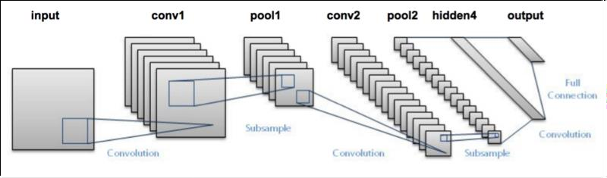

**Figure 3.3-LesNet-5**

**AlexNet(2012)**

In 2012, [AlexNet](https://papers.nips.cc/paper/4824-imagenet-classification-with-deep-convolutional-neural-networks.pdf) significantly outperformed all the prior competitors and won the challenge by reducing the top-5 error from 26% to 15.3%. The second place top-5 error rate, which was not a CNN variation, was around 26.2%.

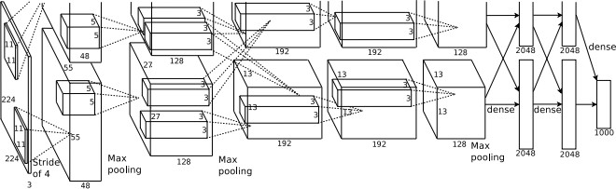

**Figure 3.4- AlexNet**

The network had a very similar architecture as [LeNet](http://yann.lecun.com/exdb/publis/pdf/lecun-98.pdf) by Yann LeCun et al but was deeper, with more filters per layer, and with stacked convolutional layers. It consisted 11x11, 5x5,3x3, convolutions, max pooling, dropout, data augmentation, ReLU activations, SGD with momentum. It attached ReLU activations after every convolutional and fully-connected layer.

AlexNet was trained for 6 days simultaneously on two Nvidia Geforce GTX 580 GPUs which is the reason for why their network is split into two pipelines. AlexNet was designed by the SuperVision group, consisting of Alex Krizhevsky, Geoffrey Hinton, and Ilya Sutskever.

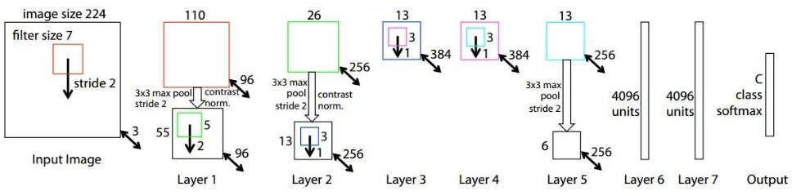**ZFNet(2013)**

Not surprisingly, the ILSVRC 2013 winner was also a CNN which became known as ZFNet. It achieved a top-5 error rate of 14.8% which is now already half of the prior mentioned non-neural error rate.

It was mostly an achievement by tweaking the hyper-parameters of AlexNet while maintaining the same structure with additional Deep Learning elements as discussed earlier in this essay.

**Figure 3.5-ZFNet**

**GoogLeNet/Inception(2014)**

The winner of the ILSVRC 2014 competition was GoogLeNet (a.k.a. Inception V1) from Google. It achieved a top-5 error rate of 6.67%! This was very close to human level performance which the organisers of the challenge were now forced to evaluate. As it turns out, this was actually rather hard to do and required some human training in order to beat GoogLeNets accuracy. After a few days of training, the human expert (Andrej Karpathy) was able to achieve a top-5 error rate of 5.1%(single model) and 3.6%(ensemble).

The network used a CNN inspired by LeNet but implemented a novel element which is dubbed an inception module. It used batch normalization, image distortions and RMSprop. This module is based on several very small convolutions in order to drastically reduce the number of parameters. Their architecture consisted of a 22 layer deep CNN but reduced the number of parameters from 60 million (AlexNet) to 4 million.

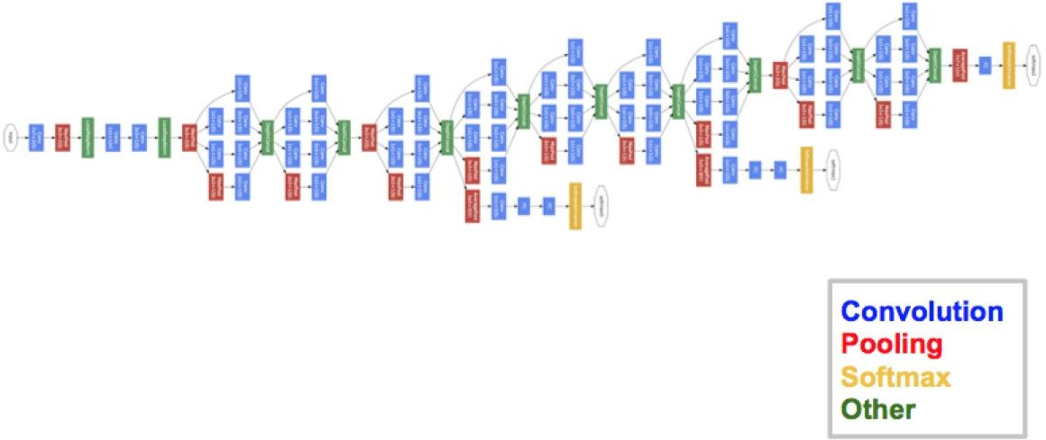

**Figure 3.6- GoogLeNet/Inception**

**VGGNet (2014)**

The runner-up at the ILSVRC 2014 competition is dubbed VGGNet by the community and was developed by Simonyan and Zisserman. VGGNet consists of 16 convolutional layers and is very appealing because of its very uniform architecture. Similar to AlexNet, only 3x3 convolutions, but lots of filters. Trained on 4 GPUs for 2–3 weeks.

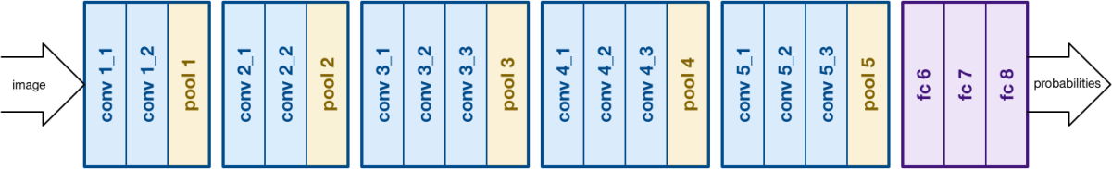 It is currently the most preferred choice in the community for extracting features from images. The weight configuration of the VGGNet is publicly available and has been used in many other applications and challenges as a baseline feature extractor. However, VGGNet consists of 138 million parameters, which can be a bit challenging to handle.

**Figure 3.7- VGGNet**

**ResNet(2015)**

At last, at the ILSVRC 2015, the so-called Residual Neural Network (ResNet) by Kaiming. He introduced a novel architecture with “skip connections” and features heavy batch normalization. Such skip connections are also known as gated units or gated recurrent units and have a strong similarity to recent successful elements applied in RNNs. Thanks to this technique they were able to train a NN with 152 layers while still having lower complexity than VGGNet.

It achieves a top-5 error rate of 3.57% which beats human-level performance on this dataset.

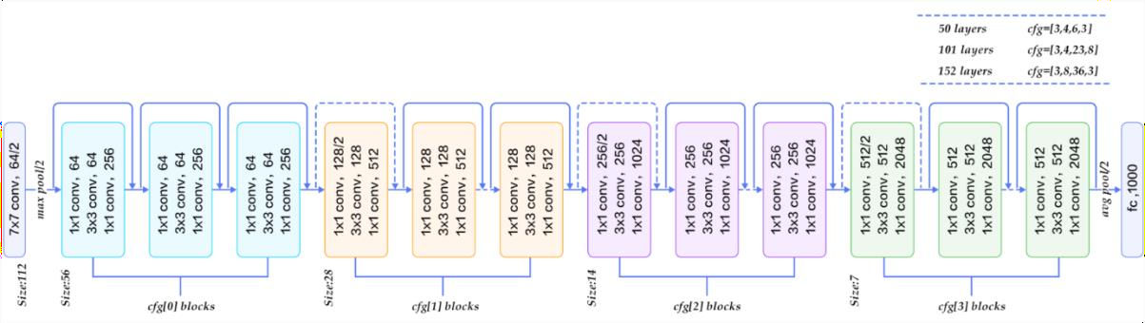

**Figure 3.8-ResNet**

AlexNet has parallel two CNN line trained on two GPUs with cross-connections, GoogleNet has inception modules ,ResNet has residual connections.

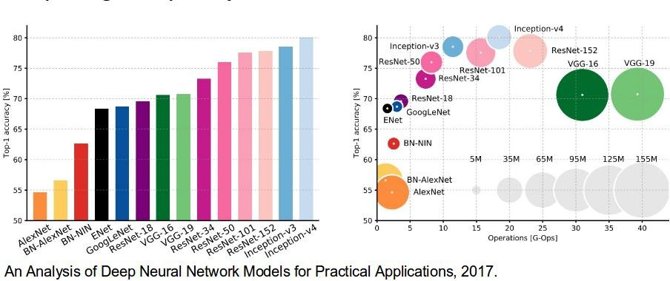

**Figure 3.9-Analaysis of practical applications**

**3.3-ADVANTAGES OF CNN**

The main **advantage of CNN** compared to its predecessors is that it automatically detects the important features without any human supervision. For example, given many pictures of cats and dogs it learns distinctive features for each class by itself. **CNN** is also computationally efficient.

Classification of Images based on their attributes is one of the most famous applications of CNN. The answer for your question is - Both supervised and unsupervised (it depends on the requirement). However, mostly supervised. Convolution Neural Networks take advantage of local spatial coherence in the input (often images), which allow them to have fewer weights as some parameters are shared. This process, taking the form of convolutions, makes them especially well-suited to extract relevant information at a low computational cost.

**CHAPTER 4**

**IMAGE PROCESSING**

Digital image processing is the use of computer algorithms to create, process, communicate, and display digital images. Digital image processing algorithms can be used to: Convert signals from an image sensor into digital images. Improve clarity, and remove noise and other artifacts.

Image processing is the technique to convert an image into digital format and perform operations on it to get an enhanced image or extract some useful information from it. Changes that take place in images are usually performed automatically and rely on carefully designed algorithms.

Image processing is a multidisciplinary field, with contributions from different branches of science including mathematics, physics, optical and electrical engineering. Moreover, it overlaps with other areas such as pattern recognition, machine learning, artificial intelligence and human vision research. Different steps involved in image processing include importing the image with an optical scanner or from a digital camera, analyzing and manipulating the image (data compression, image enhancement and filtering), and generating the desired output image.

The need to extract information from images and interpret their content has been the driving factor in the development of image processing. Image processing finds use in numerous sectors, including medicine, industry, military, consumer electronics and so on.

In medicine, it is used for diagnostic imaging modalities such as digital radiography, positron emission tomography (PET), computerized axial tomography (CAT), magnetic resonance imaging (MRI) and functional magnetic resonance imaging (fMRI). Industrial applications include manufacturing systems such as safety systems, quality control and automated guided vehicle control.

Complex image processing algorithms are used in applications ranging from detection of soldiers or vehicles, to missile guidance and object recognition and reconnaissance. Biometric techniques including fingerprinting, face, iris and hand recognition are being used extensively in law enforcement and security.

Digital cameras and camcorders, high-definition TVs, monitors, DVD players, personal video recorders and cell phones are popular consumer electronics items using image processing.

MATLAB is a general purpose programming language. When it is used to process images one generally writes function files, or script files to perform the operations. These files form a formal record of the processing used and ensures that the final results can be tested and replicated by others should the need arise.

**4.1-MATLAB IMAGE PROCESSING**

MATLAB, an abbreviation for ‘matrix laboratory,’ is a platform for solving mathematical and scientific problems. It is a proprietary programming language developed by MathWorks, allowing matrix manipulations, functions and data plotting, algorithm implementation, user interface creation and interfacing with programs written in programming languages like C, C++, Java and so on.

In MATLAB numeric computing environment. It provides a comprehensive set of reference-standard algorithms and workflow applications for image processing, analysis, visualization and algorithm development.

It can be used to perform image segmentation, image enhancement, noise reduction, geometric transformations, image registration and 3D image processing operations. Many of the IPT functions support C/C++ code generation for desktop prototyping and embedded vision system deployment.

MATLAB is a high-performance language for technical computing. It integrates computation, visualization, and programming in an easy-to-use environment where problems and solutions are expressed in familiar mathematical notation. Typical uses include:

• Math and computation

• Algorithm development

• Modeling, simulation, and prototyping

• Data analysis, exploration, and visualization

• Scientific and engineering graphics

• Application development, including Graphical User Interface building

MATLAB is an interactive system whose basic data element is an array that does not require dimensioning. This allows you to solve many technical computing problems, especially those with matrix and vector formulations, in a fraction of the time it would take to write a program in a scalar noninteractive language such as C or Fortran.

The name MATLAB stands for matrix laboratory. MATLAB was originally written to provide easy access to matrix software developed by the LINPACK and EISPACK projects, which together represent the state-of-the-art in software for matrix computation.

MATLAB has evolved over a period of years with input from many users. In university environments, it is the standard instructional tool for introductory and advanced courses in mathematics, engineering, and science. In industry, MATLAB is the tool of choice for high-productivity research, development, and analysis.

**4.2-MATLAB SYSTEM AND PARTS**

MATLAB features a family of application-specific solutions called toolboxes. Very important to most users of MATLAB, toolboxes allow you to learn and apply specialized technology. Toolboxes are comprehensive collections of MATLAB functions (M-files) that extend the MATLAB environment to solve particular classes of problems. Areas in which toolboxes are available include signal processing, control systems, neural networks, fuzzy logic, wavelets, simulation, and many others.

The MATLAB System

The MATLAB system consists of five main parts:

The MATLAB language.

This is a high-level matrix/array language with control flow statements, functions, data structures, input/output, and object-oriented programming features. It allows both "programming in the small" to rapidly create quick and dirty throw-away programs, and "programming in the large" to create complete large and complex application programs.

The MATLAB working environment.

This is the set of tools and facilities that you work with as the MATLAB user or programmer. It includes facilities for managing the variables in your workspace and importing and exporting data. It also includes tools for developing, managing, debugging, and profiling M-files, MATLAB's applications.

Handle Graphics.

This is the MATLAB graphics system. It includes high-level commands for two-dimensional and three-dimensional data visualization, image processing, animation, and presentation graphics. It also includes low-level commands that allow you to fully customize the appearance of graphics as well as to build complete Graphical User Interfaces on your MATLAB applications.

The MATLAB mathematical function library.

This is a vast collection of computational algorithms ranging from elementary functions like sum, sine, cosine, and complex arithmetic, to more sophisticated functions like matrix inverse, matrix eigenvalues, Bessel functions, and fast Fourier transforms.

The MATLAB Application Program Interface (API).

This is a library that allows you to write C and Fortran programs that interact with MATLAB. It includes facilities for calling routines from MATLAB (dynamic linking), calling MATLAB as a computational engine, and for reading and writing MAT-files.

**CHAPTER-5**

**DIGITAL IMAGE PROCESSING**

Digital image processing deals with manipulation of digital images through a digital DIP focuses on developing a computer system that is able to perform processing on an image. The input of that system is a digital image and the system process that image using efficient algorithms, and gives an image as an output. The most common example is Adobe Photoshop. It is one of the widely used application for processing digital images.

Some techniques which are used in digital image processing include:

* Anisotropic diffusion.
* Hidden Markov models.
* Image restoration.
* Independent component analysis.
* Linear filtering.
* Neural networks.
* Partial differential equations.

**5.3-Advantages of digital image:**

The processing of images is faster and more cost-effective. One needs less time for processing, as well as less film and other photographing equipment. It is more ecological to process images. No processing or fixing chemicals are needed to take and process digital images.

Some of the important applications of image processing in the field of science and technology include computer vision, remote sensing, feature extraction, face detection, forecasting, optical character recognition, finger-print detection, optical sorting, argument reality, microscope imaging, lane departure caution

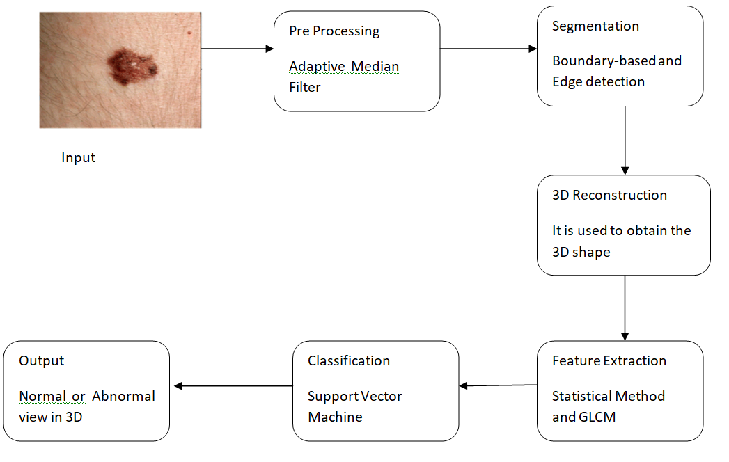

**Figure 5.1-Architecture diagram**

**CHAPTER-6**

**METHODOLOGY**

Methodology is of six processes and they are pre-processing, segmentation, medical image segmentation, 3D reconstruction, feature extraction,classification.

**6.1-PRE-PROCESSING**

Pre-processing is a common name for operations with images at the lowest level of abstraction both input and output are intensity images. The aim of pre-processing is an improvement of the image data that suppresses unwanted distortions or enhances some image features important for further processing

It includes image acquisition, preprocessing of input image, segmentation, feature extraction and presentation or classification. Image acquisition involves capturing the images in the suitable form. Preprocessing improves the quality of the data by reducing artifacts.

**6.2-SEGMENTATION**

In computer vision, image segmentation is the process of partitioning a digital image into multiple segments (sets of pixels, also known as image objects). The goal of segmentation is to simplify and/or change the representation of an image into something that is more meaningful and easier to analyze. The popular techniques used for image segmentation are: thresholding method, edge detection based techniques, region based techniques, clustering based techniques, watershed based techniques, partial differential equation based and artificial neural network based techniques etc.

**6.3-MEDICAL IMAGE SEGMENTATION**

Medical Image Segmentation. Medical Image Segmentation is the process of automatic or semi-automatic detection of boundaries within a 2D or 3D image. Furthermore, many different modalities (X-ray, CT, MRI, microscopy, PET, SPECT, Endoscopy, OCT, and many more) are used to create medical images.

**6.4-3D RECONSTRUCTION**

3D reconstruction from multiple images is the creation of three-dimensional models from a set of images. It is the reverse process of obtaining 2D images from 3D scenes. The essence of an image is a projection from a 3D scene onto a 2D plane, during which process the depth is lost

**6.5-FEATURE EXTRACTION**

Feature extraction describes the relevant shape information contained in a pattern so that the task of classifying the pattern is made easy by a formal procedure. In pattern recognition and in image processing, feature extraction is a special form of dimensionality reduction

The process of feature extraction is useful when you need to reduce the number of resources needed for processing without losing important or relevant information. Feature extraction can also reduce the amount of redundant data for a given analysis.

**6.6-CLASSIFICATION**

Image Classification is an important task in various fields such as biometry, remote sensing, and biomedical images. In a typical classification system image is captured by a camera and consequently processed. The trained classifier used to classify other images. Here SVM is used for classification. SVM works by mapping data to a high-dimensional feature space so that data points can be categorized, even when the data are not otherwise linearly separable. A separator between the categories is found, then the data are transformed in such a way that the separator could be drawn as a hyperplane.

SVM is a supervised machine learning algorithm which can be used for classification or regression problems. It uses a technique called the kernel trick to transform your data and then based on these transformations it finds an optimal boundary between the possible outputs, SVM is fundamentally a binary classification algorithm. For example, image filtering, where an input image is passed through a Laplacian filter to be sharpened.

**CHAPTER-7**

**MODULES**

* Input raw image
* Noise reduction
* Contrast enhancement using histogram equalization
* Preprocessing
* Filtering of cells
* Image segmentation
* Database
* Image Recognition

**7.1-MODULES DESCRIPTION:**

**Input raw image**

Input the image that is taken from the database

**Noise reduction**

We used median filtering method to reduce the paper and salt noise. We have used 3x 3 masks to get eight neighbors of a pixel and their consistent gray value.

**Contrast enhancement using histogram equalization**

Using histogram equalization method the difference of each image is being enhanced. The function used to improvement that is J=histeq(k); histeq enhances the contrast of the images by converting the values in an intensity image. When image pixel intensity of 8-neibourgh connectivity, we supply a preferred histogram, histeq chooses the grayscale conversion T to minimize

│c1 (T (k))-c0 (k) │

In below we state the change of histogram from original image and after smearing the contrast enhancement using histogram equalization.

**Cell Segmentation**

Matlab toolbox function delivers a function called region props(). It measures a set of properties for each labeled region in the label matrix. We use bounding box to measure the properties of the image region. After labeling the connecting components, the region will be removing from the input image.

**Preprocessing**

The preprocessing phase consists of conventional techniques for example image filtering, improving the visibility of the image and some enhancement in image. Some of the basic filters are applied on the area of number plate that is Histogram Equalization, Median filter and Morphological filters**.** Histogram equalization is one of the most important part of the software for any image processing. It improves contrast and the goal of histogram equalization is to obtain a uniform histogram. This technique is used on a whole image.

The median filter is normally used to reduce noise in an image; it often does a better job than the mean filter of preserving useful detail in the image. Median filtering is a simple and very effective noise removal filtering process. Its performance is particularly good for removing shot noise. Shot noise consists of strong spike like isolated values. This class of filter belongs to the class of edge preserving smoothing filters which are non-linear filters. This filter smooths the data while keeping the small and sharp details.

**Filtering of Cells**

Now the black and white image of the wbc can be obtained. It has been cropped to a rectangular shape in which it enhances the algorithm to be more uniformed in the further stages. The non-digits substance which appears in the image is caused by the noise (quantization that will transform to „Black‟), object or substance which is not digits/characters such as screws, sand, water droplet, frame lines, effects on JPEG compression. By Filtering, the unwanted substances or noise can be removed or filtered out that is not a character or digits. Lastly, the image is only left with cells and digits in which we are interested.

The 2 stages for the algorithm is as follows:

1. Remove out the small objects or connected components.
2. Identify the frame line that is connected to the digits and separate it. Identify and remove away the small connected objects

**Image segmentation**

In order to extract and analyzed the object characteristic, image segmentation is used, the process which need to partition the image into different parts that will have a strong correlation with the objects.

Segmentation process can be categorized into several parts. Firstly is the global knowledge of an image. The feature of the image is represented by a histogram. Secondly, in the boundary-based segmentation edge detection is used to obtain the region contours and the objects will construct from the obtain contours. Another one is edge-based segmentation. For this paper, first category segmentation method is being used which is by using threshold.

**Database**

It is a collection of information or data which it is being orderly organize, thus it can be accessed easily and updated. Database can be in the form of text, contents and images and is needed to make sure that the image space can contained enough characters which have been extracted and the vehicle number plate number stored in the excel sheet for the purpose of comparison. The database would be large enough in order to improve the accuracy and better chances of obtaining the correct result. The class recognition will check if the computed ratio is correct. It will ignore the class if the image thresholding is too low. If the class has match correctly, it will be compare with data set in the predefined database and provide an output if the image is recognized correctly.

**Image Recognition**

In this step, the extracted characters are resized to fit the characters into a window. For the paper, each character is normalized to the size of (50x30) binary image and then follow by reshape to standard dimension before sending the data set to neural network for training. Its performance is particularly good for removing shot noise. Shot noise consists of strong spike like isolated values. This class of filter belongs to the class of edge preserving smoothing filters which are non-linear filters. This filter smooths the data while keeping the small and sharp details.

**CHAPTER 8**

**CONCLUSION**

**REFERENCES**

1. Zulfikar Zulfikar and Zulhelmi Zulhelmi, Statistical Investigation of Skin Image for Disease Analyzing in Rural Area Using Matlab ,2017.
2. Kyamelia Roy Sheli,Sinha Chaudhuri Sanjana Ghosh, Swarna Kamal Dutta Proggya Chakraborty Rudradeep Sarkar, Skin Disease detection based on different segmentation Techniques ,2019.
3. Archana Ajith, Vrinda Goel, Priyanka Vazirani, Dr. M. Mani Roja,Digital dermatology-Skin disease detection model using image processing,2018.
4. D.N.V.S.L.S. Indira, JYOTSNA SUPRIYA, Detection and analysis of skin cancer using wavelet techniques,2011.
5. Nikos Petrellis, Using color signatures for the classification of skin diseases,2018.
6. Soniya Mane, Dr. Swati Shinde, A Method for Melanoma Skin Cancer Detection Using Dermoscopy Images, 2018.
7. Stepanka Barotova, Martin Drahansky, Fingerprint damage localizer and detector of skin diseases from Finger print images,2017.